**05 - 2D Vortex**

2D Vortex from Pirozzoli was implemented. This inviscid Vortex is transported based on u0 following this set of equations.

*r = sqrt((X - Fluid.Vortex_x0).^2 + (Y - Fluid.Vortex_y0).^2);*

*r_norm = r/Fluid.r_v;*

*u_exact = Fluid.U_0.*(1 - Fluid.Ma_vortex./Fluid.Ma*(((Y - Fluid.Vortex_y0)./Fluid.r_v).*exp((1 - r_norm.^2)/2)));*

*v_exact = Fluid.U_0.*(Fluid.Ma_vortex./Fluid.Ma*(((X - Fluid.Vortex_x0)./Fluid.r_v).*exp((1 - r_norm.^2)/2)));*

*w_exact = u_exact*0;*

*P_exact = Fluid.P_0.*((1 - ((Fluid.gamma - 1)/2*Fluid.Ma_vortex^2).*exp((1 - r_norm.^2))).^(Fluid.gamma/(Fluid.gamma - 1)));*

*rho_exact = Fluid.rho_0*((1 - ((Fluid.gamma - 1)/2*Fluid.Ma_vortex^2).*exp((1 - r_norm.^2))).^(1/(Fluid.gamma - 1)));*

*T_exact = P_exact./(rho_exact*Fluid.R_specific);*

According to Pirozzoli, the aspect ratio L/r_v = 24 for X and 12 for Y dimension with Ma = 0.1 centered at the origin.

1. **2D Vortex results**

After 3 flow through times the vortex is no longer centered at 0 and it is moved on X and Y. Pirozolli reported numerical issues with second order on space schemes, and also with divergence schemes. Furthermore, varying meshes were used to capture the vortex.

In fact, mesh had to be increased up to 128 to get and capture relatively well the vortex. Even if AR is lowered down to get a greater vortex, the mesh size needs to be even grater in order not to distortion the vortex.

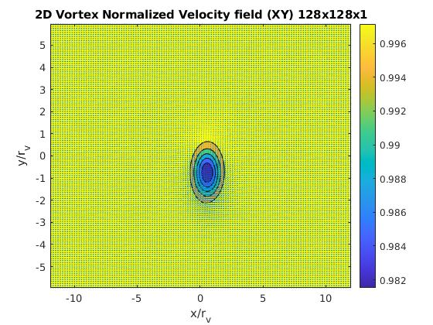

Reference for Pirozzoli was the bottom right plot from the following figure, i.e vertical speed in x/r_v = 0.5 (center of the vortex). In fact this is the speed and position to assess the error with respect to exact solution.

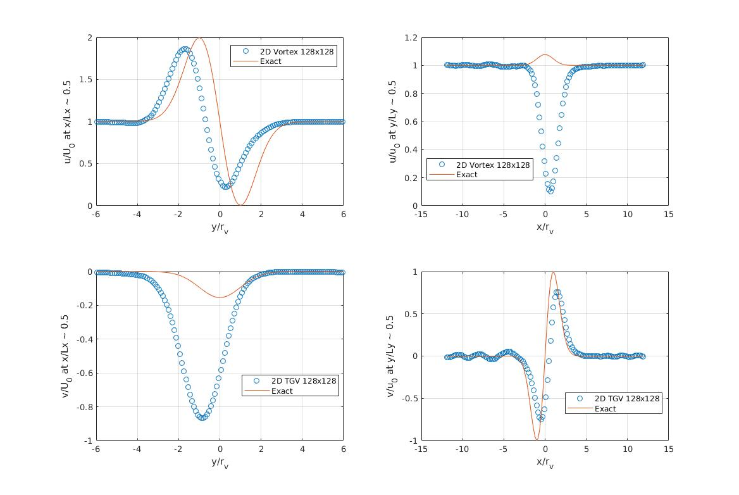

Although Ke should be constant, it is increasing slightly and this should not happen - investigation to follow.

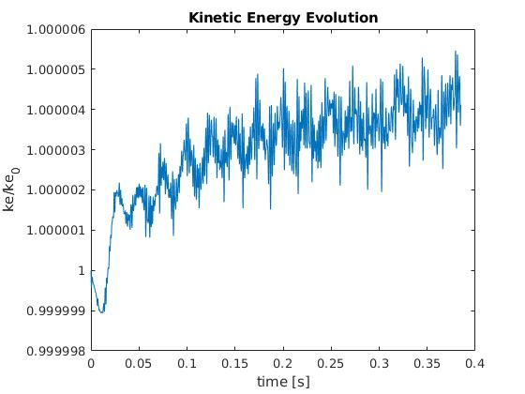

* Results at 256x256

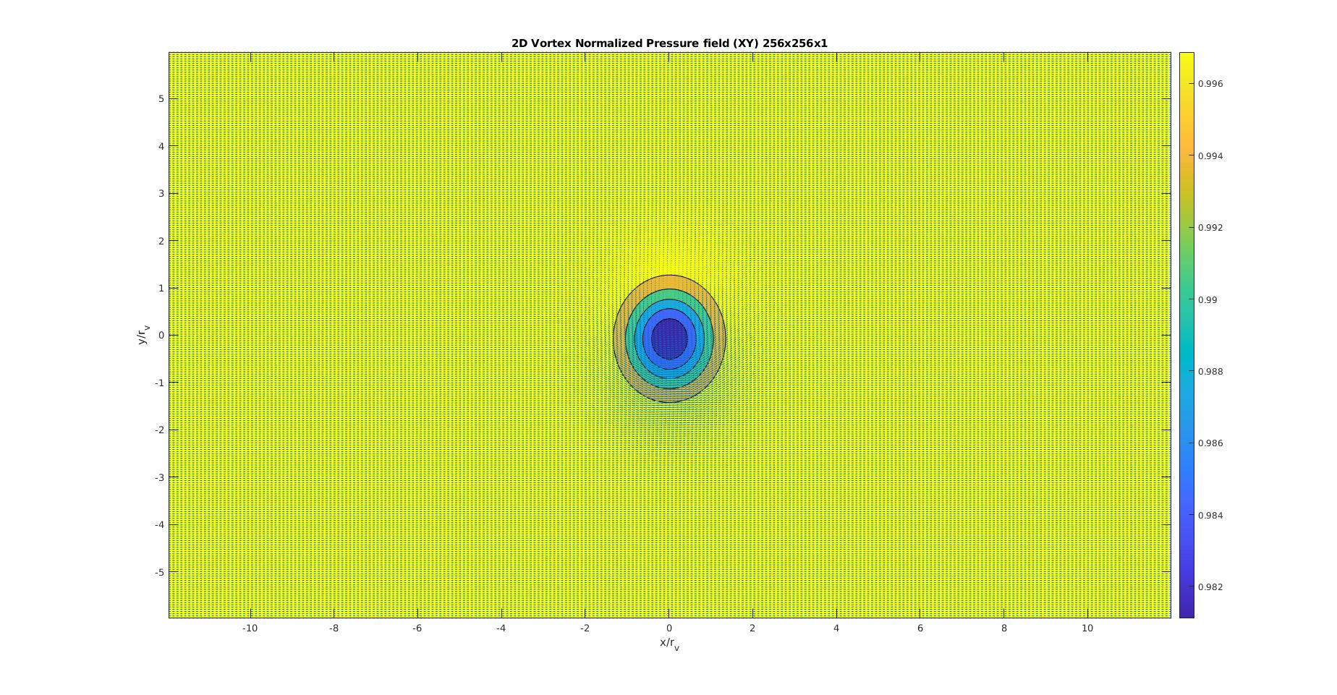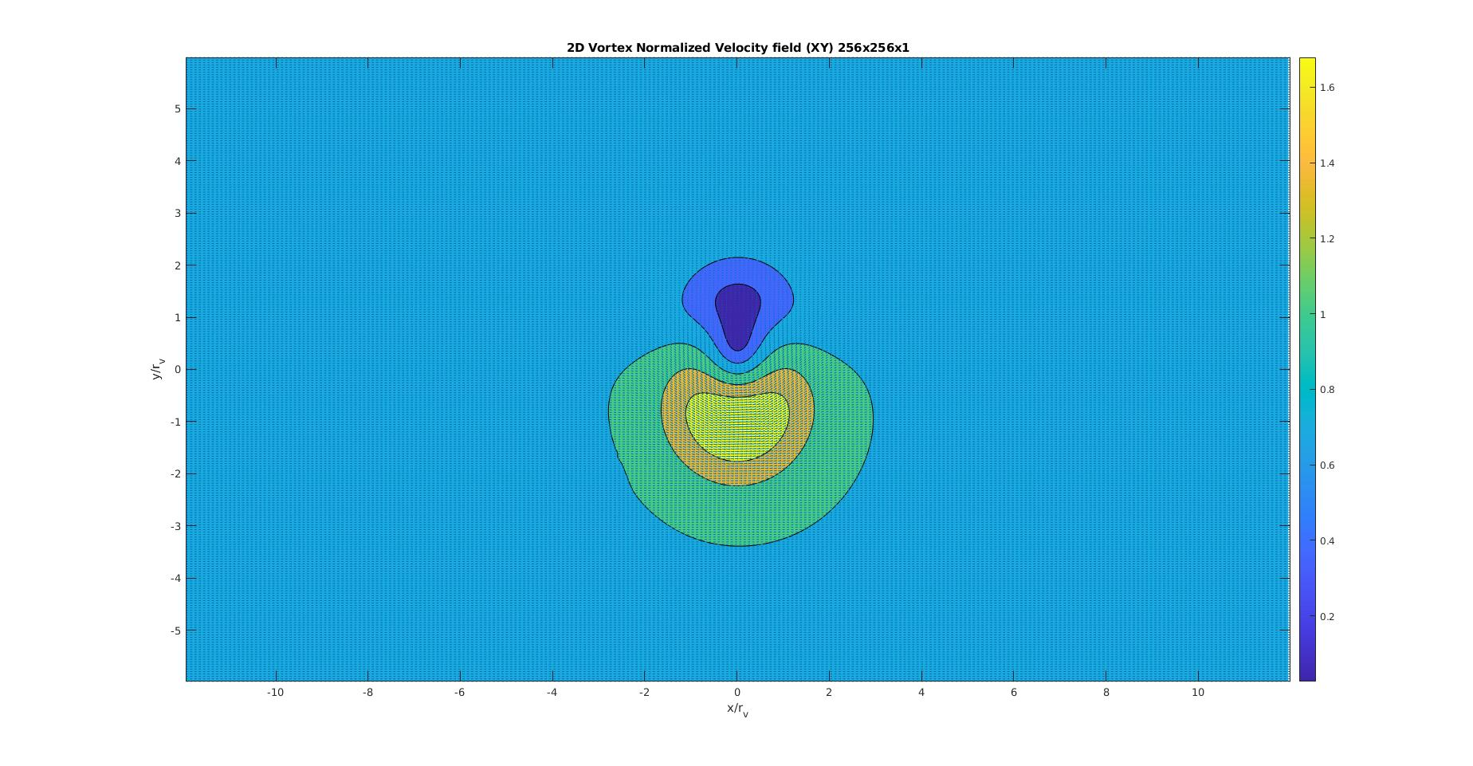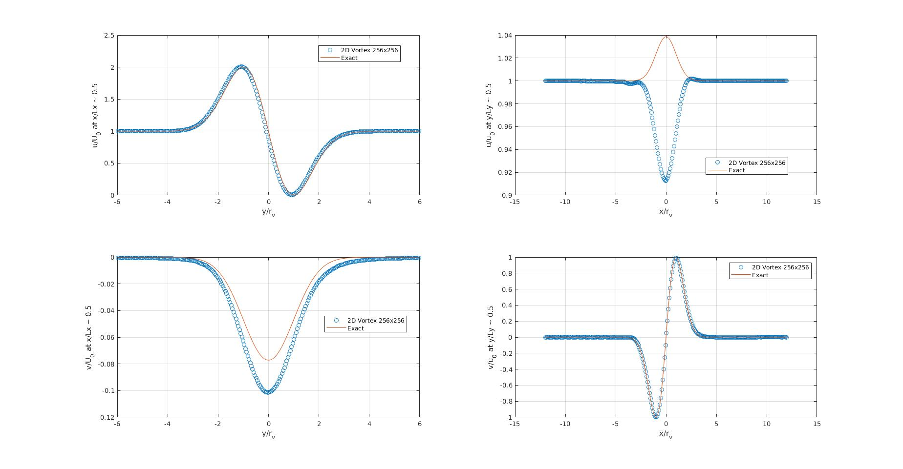

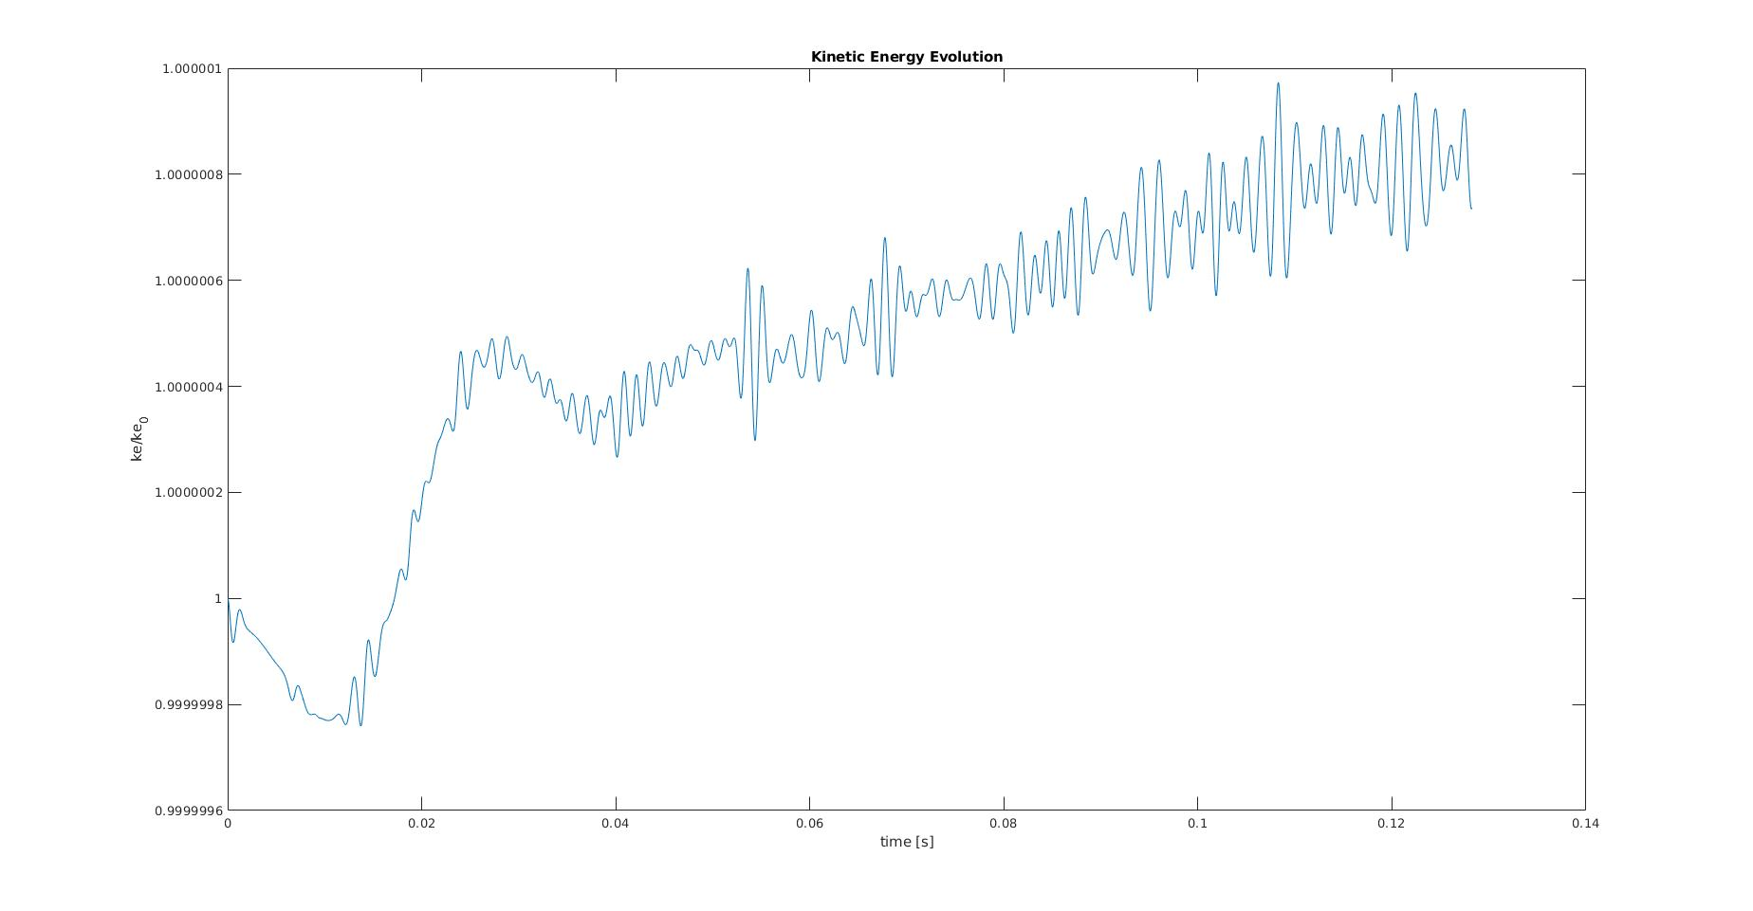

1. **Spatial accuracy**

Error was accounted only for a mid plane of x/r_v = 0.5 with vertical velocity.

Although errors were great, they followed exactly an order 2 shape. The results were as below for a 128 and 256 grid points in X and Y.

*u_L1_norm_error_total = 16.7566 4.4704*

*v_L1_norm_error_total = 2.7111 0.5660*

*u_L2_norm_error_total = 12.9450 3.4637*

*v_L2_norm_error_total = 2.2012 0.5207*

*Order L1 is 1.9063*

*Order L2 is 1.902*

